Project Overview
- Project Description: A web app that will have multiple pages , a mood tracking page which will allow users to select a mood on a scale , fill in keywords based on their mood as well as submit some notes, on this page they may get articles recommended to them based on submissions. The next page will be a tamogochi style game that allows users to care for a cat, feed , pet , etc.
- Client: NHS UK
- Project Manager: Jeremy
- Development Manager: Cameron
- Date: 28th January 2025 – 7th March 2025

Project Scope
- Objective:
  - To create an interactive tool for customers of NHS mental health services in Gateshead to use in order to improve and maintain a positive mental health. This tool should aid the NHS not attempt to replace it.
- Features & User Stories:
  - To be able to log mood in both a granular and non granular manner
  - To be given recommendation on NHS articles and resources based on my mood history
  - To be able to pet, feed and interact with the chosen being within the game
  - To be able to view my mood log
  - To be able to register , login and logout

Agile Methodology
- Agile Framework:
  - Agile / SCRUM
- Sprint Duration:
  - 1 week per sprint with Tuesdays and Saturdays being review / meeting
- Team Members:
  - All normal documented roles apply with Jeremy being the SCRUM master

User Stories
  - Title: App From The Perspective Of A Practitioner
  - As a GP / Therapist,
I want be able to reference patients to this recourse to assist me and the patient on maintaining a positive mental health
So that I can give them more effective care
  - Acceptance Criteria:
    - The website is inclusive to all (disabilities: eg deaf or blind )
    - Personalised experience
    - Easy / intuitive to use
  - Priority: [High]

  - Title: User System
  - As a end user,
I want be able to register , log in and log out
So that I can access the content of the site
  - Acceptance Criteria:
    - Users can register with a custom username and password
    - username and password are stored on the database
    - password is encrypted
    - users can login with their custom username and password combination
    - all data is attached to the “profile” based on the combination
  - Priority: [High]

Title: User Progress
  - As a end user,
I want to be able to access my previous progress
So that I can track my progress of my mental health
  - Acceptance Criteria:
    - Progress is stored effectively
    - Progress can be retrieved even after a logout
Priority: [High]

Technical Documentation
- System Architecture:
  - A React Frontend with a ExpressJS API with a sqllite database.
  - Frontend -POST→ API → Database (or vice versa)
Flow Charts
    - Login
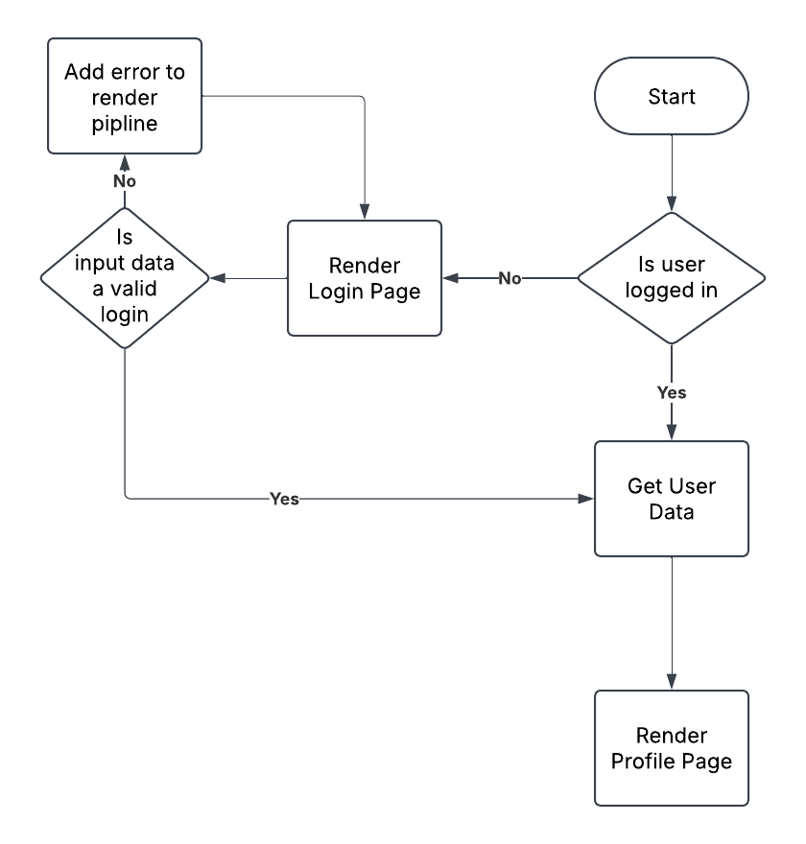
    - Article Recommendation

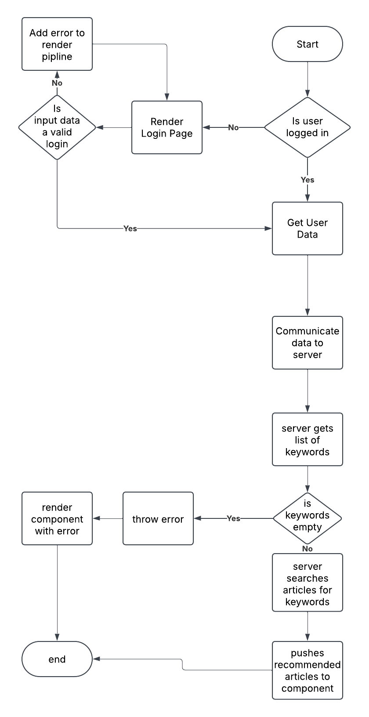

- API Documentation:

POST /register
- Description: Register a new user by providing a username and password. The password is hashed before storing in the database.
- Request Body:
  - username (string): The user's chosen username.
  - password (string): The user's password.
- Responses:
  - 201 Created: If the user is successfully registered.
    - Example: { "message": "User registered successfully" }
  - 500 Internal Server Error: If an error occurs while hashing the password or saving the user to the database.
    - Example: { "error": "Hashing error" }

POST /login
- Description: Log in a user by verifying their username and password. Returns a JWT token if successful.
- Request Body:
  - username (string): The user's username.
  - password (string): The user's password.
- Responses:
  - 200 OK: If the login is successful, returns a JWT token.
    - Example: { "token": "<JWT_TOKEN>" }
  - 400 Bad Request: If the username does not exist or the password is incorrect.
    - Example: { "error": "Invalid username or password" }

GET /profile
- Description: Get the profile information of the logged-in user. Requires a valid JWT token.
- Headers:
  - Authorization (string): Bearer token containing the JWT.
- Responses:
  - 200 OK: If the token is valid, returns the user's profile data.
    - Example: { "message": "Welcome to your profile!", "user": { "id": 1, "username": "example" } }
  - 401 Unauthorized: If no token is provided.
    - Example: { "error": "Token required" }
  - 403 Forbidden: If the token is invalid or expired.
    - Example: { "error": "Invalid or expired token" }

Moods

GET /userMoods
- Description: Get the mood entries for the logged-in user. Requires a valid JWT token.
- Headers:
  - Authorization (string): Bearer token containing the JWT.
- Responses:
  - 200 OK: If the token is valid, returns the list of mood entries.
    - Example: { "moods": [{ "id": 1, "mood": "Happy", "keywords": "joy", "notes": "Feeling great!", "visible_to_gps": true }] }
  - 401 Unauthorized: If no token is provided.
    - Example: { "error": "Token required" }
  - 403 Forbidden: If the token is invalid or expired.
    - Example: { "error": "Invalid or expired token" }

POST /saveMood
- Description: Save a new mood entry for the logged-in user. Requires a valid JWT token.
- Request Body:
  - mood (string): The mood description (e.g., "Happy", "Sad").
  - keywords (string): Comma-separated keywords associated with the mood.
  - notes (string): Additional notes for the mood entry.
- Headers:
  - Authorization (string): Bearer token containing the JWT.
- Responses:
  - 201 Created: If the mood is saved successfully.
    - Example: { "message": "Mood saved successfully" }
  - 401 Unauthorized: If no token is provided.
    - Example: { "error": "Token required" }
  - 403 Forbidden: If the token is invalid or expired.
    - Example: { "error": "Invalid token" }

Articles

GET /recommendedArticles
- Description: Get a list of articles that match the provided keywords.
- Parameters:
  - keywords (string): A comma-separated list of keywords to search for in the articles.
- Responses:
  - 200 OK: If articles matching the keywords are found, returns the list of recommended articles.
    - Example: { "recommendedArticles": [{ "title": "Article 1", "content": "This is the article content..." }] }
  - 400 Bad Request: If no keywords are provided.
    - Example: { "error": "No keywords provided" }
  - 500 Internal Server Error: If there is an error reading the articles directory.
    - Example: { "error": "Failed to read articles directory" }
- Database Design:
  - ER Diagram
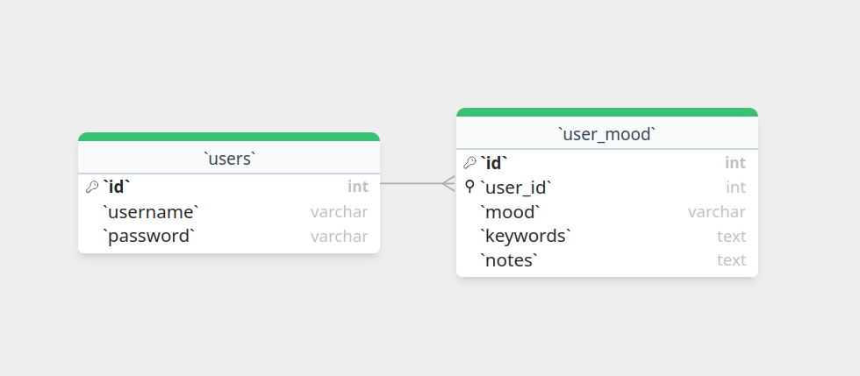
Data Dictionary
  - users
Field Name | Data Type | Description | Example | Constraints
id | INTEGER | A unique identifier for a user | 8 | Primary key,AUTOINCREMENT
username | TEXT | A username | “admin” | NOT NULL
password | TEXT | A password | “password” | NOT NULL

  - user_mood
Field Name | Data Type | Description | Example | Constraints
id | INTEGER | A unique identifier for the mood data | 5 | Primary Key,AUTOINCREMENT
user_id* | INTEGER |  |  | REFERENCES "users"("id")
mood | TEXT | A single word describing mood from slider | depressed | NOT NULL
keywords | TEXT | A list of keywords stored as a string (processed by server to) | “this,is,the,example” | NOT NULL
notes | TEXT | A chunk of text | Lorum ipsum

- Code Standards:
  - Function names in PascalCase.
  - Indentation is done via tab
  - Function signatures should be done using Kernighan and Ritchie style

Test Plan
- Types of Tests:
  - Unit testing using a testing framework for example testcafe
- Test Cases:
  - Any API endpoint failure such as 404 errors
  - API: Erroneous data, Correct data and bounds errors
  - Component rendering correctly

Risks & Mitigations
- Risk:
  - That information given by articles is either incorrect / not helpful or too vague
- Probability:
  - [Medium]
- Impact:
  - [High]
- Mitigation Plan:
  - We will only refer to the resources written by mental health professions by the NHS or the resources provided to us by the NHS for our articles
- Risk:
  - That user data is compromised
- Probability:
  - [High]
- Impact:
  - [High]
- Mitigation Plan:
  - We shall encrypt all data with a JWT key only known to the backend at the API level

